Welcome to Asian Transplantation Week 2023
On behalf of the Organizing Committee, it is our great honor and pleasure to invite you to Asian Transplantation Week 2023 (ATW 2023) which will be held from November 15 (Wed) to 18 (Sat), 2023 at the Conrad Hotel, Seoul, Korea.
We successfully hosted the ATW congress as an in-person meeting in 2022 with more than 1,000 participants thanks to the solid support and interest of all our members and participants.
For this year’s edition, under the theme “Asian Transplantation: Beyond Pandemic, New Opportunities,” the ATW 2023 Organizing Committee is preparing an exciting scientific program including Plenary Sessions, Special Sessions, Postgraduate Courses, and Concurrent Symposiums. ATW 2023 will cover hot topics and up-to-date findings in the various fields of transplantation, and offer all participants with the chance to not only hear renowned speakers and delegates, but also share their thoughts and ideas with the transplantation community. In particular, we have extended the duration of the ATW congress to four days this year, and are preparing a “Live Surgery for Robotic Kidney Transplantation” session to be held on the first day of the congress across three transplantation centers in Seoul, Korea. This special program will offer participants an exceptional opportunity to actively engage in witnessing and learning the latest in surgical skills.
It is the wish of the Korean Society for Transplantation, the organizing society of ATW, to have the privilege to share its experience and knowhow with colleagues from all over the world through ATW 2023. We are devoting our utmost effort to realizing our ultimate goal of making the ATW congress the leading transplant-related academic congress in the Asia-Pacific region.
Please save the date in your calendar and join us this November. We look forward to meeting you at ATW 2023!
Sincerely,
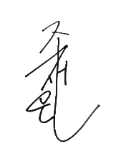 |  | 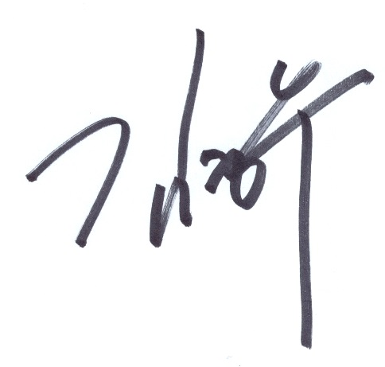
Jae-Won Joh  Congress President  ATW 2023 |  | Myoung Soo Kim  Chair, Organizing Committee  ATW 2023

Overview
Congress Title | Asian Transplantation Week 2023 (ATW 2023)
Date | November 15 (Wed) – 18 (Sat), 2023
Venue | Conrad Seoul, Seoul, Korea  *15(Wed): Live Surgery for Robotic Kidney Transplantation at three transplantation centers in Seoul
Theme | Asian Transplantation: Beyond Pandemic, New Opportunities
Website | www.atweek.org
Official Language | English
Hosted by | The Korean Society for Transplantation (KST)
Important Dates | Abstract Submission Period May 17 (Wed) – August 2 (Wed), 2023  Abstract Acceptance Notice September 6 (Wed), 2023  Early-Bird Registration Period June 28 (Wed) – September 20 (Wed), 2023  Pre-registration Period September 21 (Thu) – November 8 (Wed)
Secretariat Contact Information | ATW 2023 Secretariat  InSession International Convention Services, Inc.  4Fl., 10, Yeoksam-ro 7-gil, Gangnam-gu, Seoul 06244, Korea  Tel: +82-2-3452-7245  E-mail: atweek@insession.co.kr

Scientific Program: https://atweek.org/program-at-a-glance/
1st Newsletter: https://www.insession.co.kr/newsletter/atweek/2023/news01.html

